Slide 1

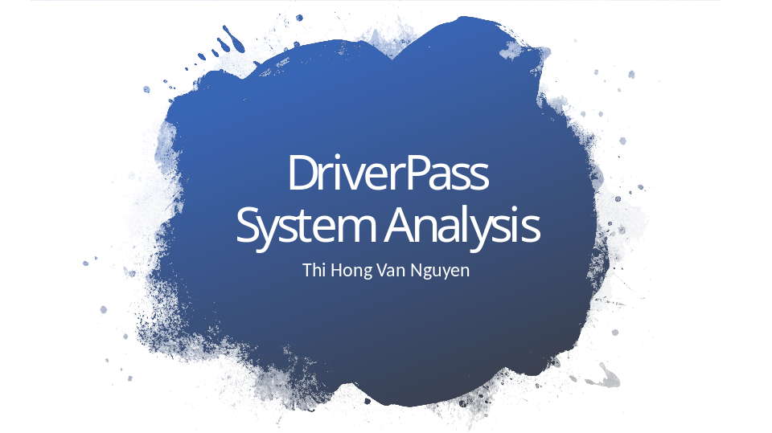

[No speaker notes required for this slide.]

Slide 2

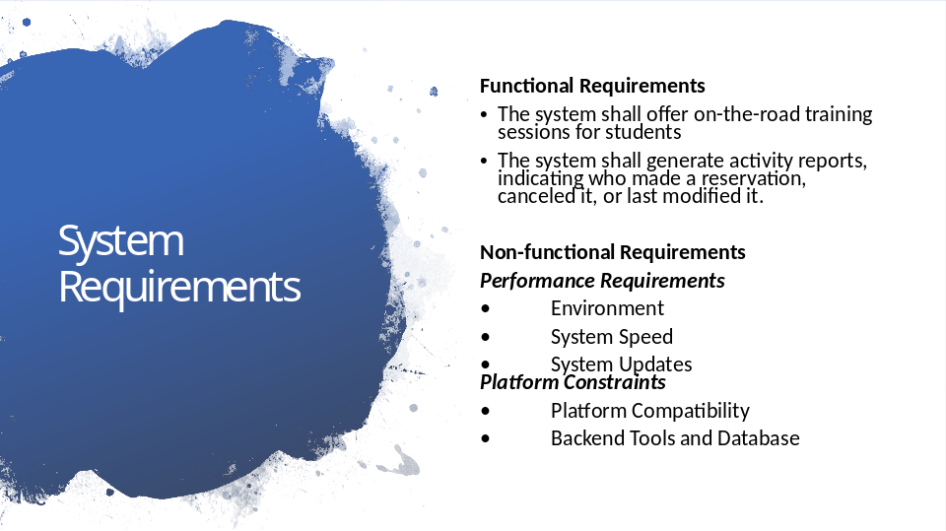

First, let's discuss the functional requirements. DriverPass aims to provide comprehensive training for students, and one of the core functionalities is on-the-road training sessions. The system will enable students to book driving lessons, specifying their preferred day and time. Additionally, the system will generate activity reports, allowing DriverPass to track reservations, cancellations, and modifications, ensuring transparency and accountability.
Moving on to the non-functional requirements, we have identified two key areas: performance requirements and platform constraints. Under performance requirements, we consider the environment in which the system will operate. This encompasses factors such as the stability and speed of the system, ensuring smooth and efficient operations. Furthermore, system updates will be crucial to keep the platform up-to-date, incorporating any necessary improvements or bug fixes.
Regarding platform constraints, the DriverPass system must be compatible with various platforms to cater to a wide range of users. This includes ensuring compatibility with different devices and operating systems, enabling seamless access for students, instructors, and administrators. Additionally, the backend tools and database need to be carefully chosen to support the system's functionalities, ensuring efficient data storage, retrieval, and management.
By meeting these requirements, the DriverPass system will address the critical needs outlined by the company. It will offer comprehensive on-the-road training sessions, empowering students to enhance their driving skills. The activity reports will provide insights into the reservation process, ensuring transparency and accountability. The performance requirements will guarantee a smooth and efficient user experience, while the platform constraints will ensure compatibility across various devices and operating systems.
The functional and non-functional requirements we have discussed today align closely with DriverPass's vision of providing a robust and user-friendly system for driver training. By incorporating these requirements, we can create a system that meets the needs of students, instructors, and administrators alike, facilitating a seamless and effective learning experience.

Slide 3

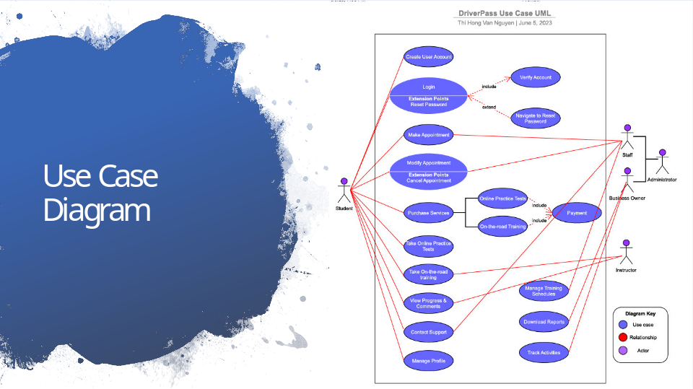

The diagram illustrates the various actions and functions available to users within the DriverPass app. Users can engage in tasks such as creating an account, logging in, scheduling appointments, purchasing services, taking practice tests, participating in on-the-road training, managing their profile, checking test results and progress, contacting support, and more. In addition, the diagram includes administrative capabilities, such as managing appointments and training schedules, generating reports, and monitoring activities. The primary user, known as the student, is at the center of the diagram, while other personnel, including staff, business owner, administrator, and instructor, play different roles within the system. The staff and business owner are depicted as part of the administrator's responsibilities.

Slide 4

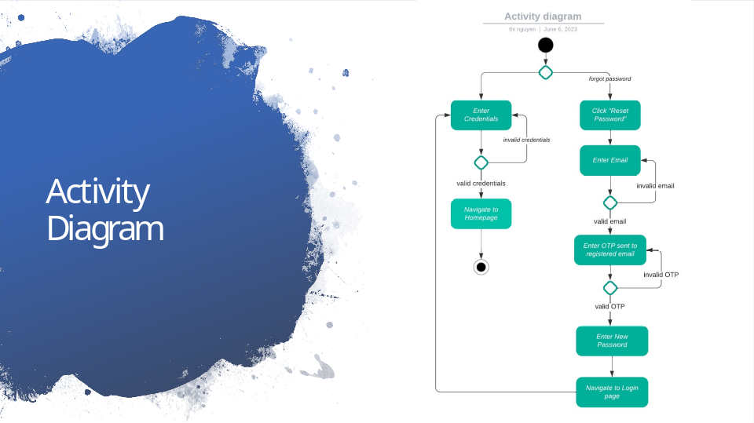

Next, I would like to present one of the key functionalities of DrivePass: the user login process. This particular aspect is crucial as it allows users to securely access their accounts and utilize the app's features. Let's delve into the flow depicted in the diagram.

When users land on the Login page, they are presented with two options. First, they can enter their username and password to log in directly. Alternatively, if they have forgotten their password, they can click on the "reset password" link for assistance. This link takes them to a password reset page.

On the password reset page, users are prompted to enter their registered email address. If the email provided is invalid or not associated with any account, an error message is displayed to guide them. However, if the email is valid, users will receive a One-Time Password (OTP) via email. Having received the OTP, users can then enter it on the password reset page. If the OTP is valid, they gain the ability to reset their password. Once the password is successfully reset, users are redirected back to the Login page, where they can proceed to log in using their updated credentials.

In cases where users choose to log in using their username and password, the system verifies the provided credentials. If the credentials are invalid, an error message is shown, prompting users to review their inputs. However, if the username and password are correct, users are authenticated, and they are directed to the Homepage, where they can explore and utilize the various features and services provided by DrivePass.

Slide 5

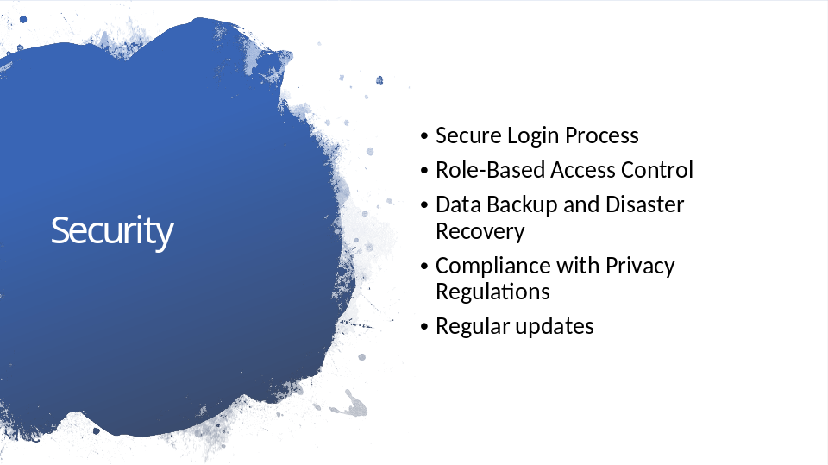

Next, I want to present to you the security features of the DriverPass system design. As you know, security is a top priority when it comes to any online platform, and DriverPass is no exception. Our design incorporates several key measures to ensure the safety and protection of user information. Let's dive into the details!
First and foremost, we have implemented a secure login process. This means that when users log in to the system, they go through a verification process to ensure that they are the rightful owners of their accounts. We understand the importance of keeping personal information safe, so we have taken extra steps to make sure that only authorized individuals can access the system.
Next, we have implemented role-based access control. This means that different users have different levels of access based on their roles within the system. This ensures that each user can only access the features and information that are relevant to their specific responsibilities. By limiting access, we minimize the risk of unauthorized actions and protect the privacy of sensitive data.
Data backup and disaster recovery are also critical components of our system design. We understand that data loss can be catastrophic, so we have implemented regular backups of user data. This way, even in the event of a system failure or unforeseen event, we can restore the data and ensure that users do not suffer from any loss of information. We take the security of your data seriously and strive to maintain its integrity at all times.
In today's world, privacy regulations are becoming increasingly important. We want to assure you that DriverPass complies with all relevant privacy regulations, such as the General Data Protection Regulation (GDPR). This means that we obtain user consent for data processing, provide mechanisms for data subject rights, and ensure that your personal information is handled in accordance with the highest privacy standards.
Finally, regular updates are a crucial part of our system design. We understand that new security threats emerge constantly, and we are committed to staying ahead of them. By regularly updating our system, we can address any vulnerabilities that may arise and ensure that our platform remains secure and resilient.

Slide 6

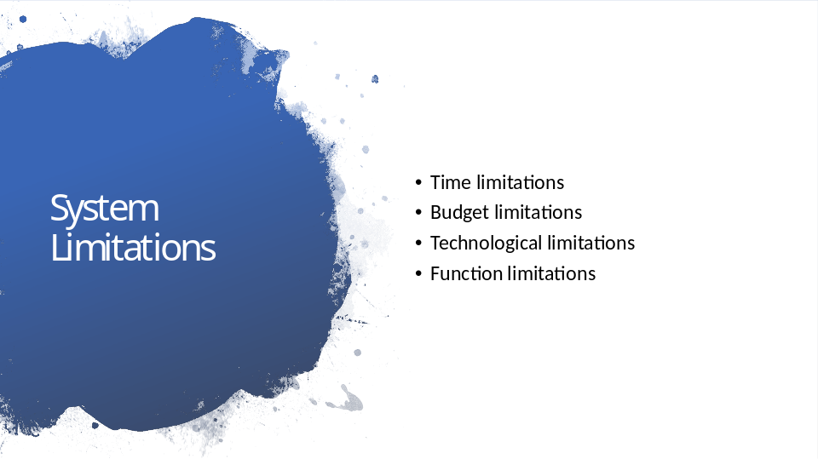

As we evaluate the design of the DriverPass system, it is crucial to acknowledge the limitations that we have identified. These limitations may impact certain aspects of the project. Let's discuss these limitations in a non-technical manner to better understand their significance.
Firstly, we have time limitations. This means that the development, testing, and implementation of the system may be constrained by time. The project might have a fixed timeline, and there could be limitations on the amount of time available for each phase, such as requirements gathering, design, development, and testing. It's important to be mindful of these time constraints as we work towards delivering a successful system.

Next, we have budget limitations. Financial constraints can impact the allocation of resources to the development and maintenance of the DriverPass system. Limited funding may affect the scope of the project, the selection of technologies, and even the level of system security. We need to carefully consider these budgetary limitations as we make decisions throughout the project.

Another limitation we need to address is technological limitations. The chosen technologies, frameworks, and programming languages may have certain restrictions or limitations that could affect the system design. For instance, certain technologies may not seamlessly integrate with third-party services or may not support specific features required by the system. It's essential to understand and navigate these technological limitations to ensure a robust and effective system.

Lastly, we have functional limitations. While the functional requirements have been outlined, it is important to note that they may not cover all possible scenarios or user needs. Some specific user requirements or edge cases may not be addressed within the scope of the initial design. These functional limitations could impact the system's ability to cater to all possible user scenarios effectively. We need to be aware of these limitations and find ways to mitigate their impact.

